Published: 27-Jun-2012
Fuel Charging and Controls - Turbocharger - ID4 2.4L Diesel - Turbocharger
Removal and Installation
Removal
- WARNING: Do not work on or under a vehicle supported only by a jack. Always support the vehicle on safety stands.
Raise and support the vehicle.
For additional information, refer to: Lifting (100-02 Jacking and Lifting, Description and Operation).

- Remove the air cleaner outlet pipe.
For additional information, refer to: Air Cleaner Outlet Pipe (303-12 Intake Air Distribution and Filtering - ID4 2.4L Diesel, Removal and Installation).

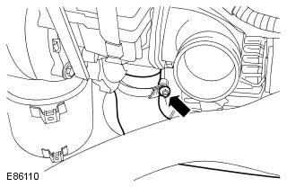 | - Disconnect the charge air cooler inlet hose.  - Release the clip.

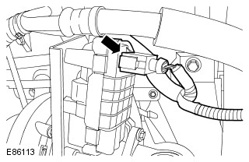 | - Disconnect the turbocharger electrical connector.

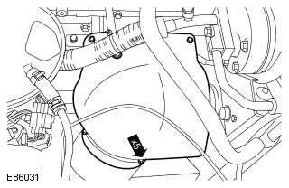 | - Remove the turbocharger heat shield.  - Remove the 5 bolts.

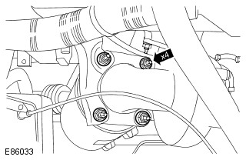 | - Remove and discard the 4 nuts from the catalytic converter.

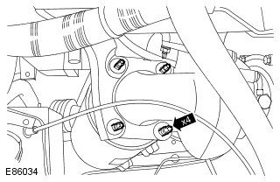 | - Remove and discard the 4 studs from the catalytic converter.

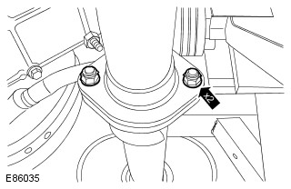 | - Release the catalytic converter.  - Remove and discard the 2 nuts.

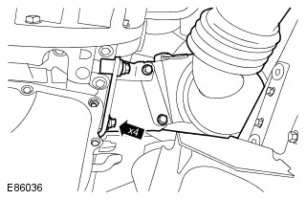 | - Release the catalytic converter.  - Loosen the 4 bolts.

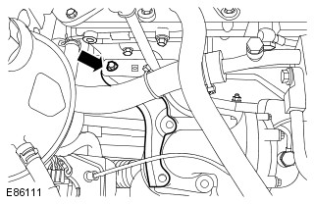 | - Remove the catalytic converter bracket.  - Remove the bolt.

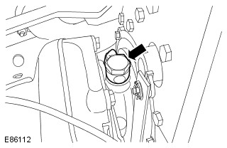 | - CAUTION: Make sure that all openings are sealed. Use new blanking caps.  Disconnect the turbocharger oil supply pipe.  - Remove the banjo bolt.  - Remove and discard the sealing washers.

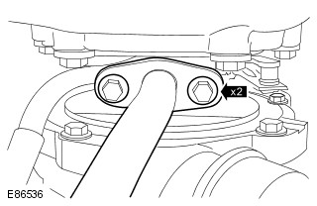 | - CAUTION: Make sure that all openings are sealed. Use new blanking caps.  Release the turbocharger oil return tube.  - Remove the 2 bolts.  - Remove and discard the gasket.

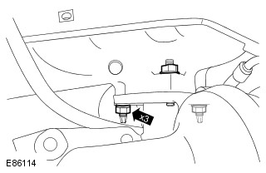 | - Remove and discard the 3 turbocharger nuts.

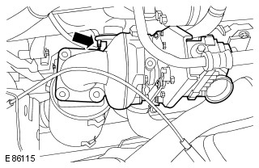 | - CAUTION: Make sure that all openings are sealed. Use new blanking caps.  Remove the turbocharger.  - Remove and discard stud.  - Remove and discard the gasket.

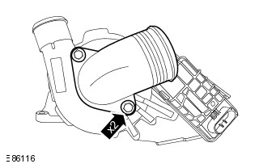 | - NOTE: Do not disassemble further if the component is removed for access only.  Remove the turbocharger inlet duct.  - Remove the 2 bolts.
Installation
- Install the turbocharger inlet duct.
  - Tighten to 23 Nm (17 lb.ft).

- NOTE: Remove and discard the blanking caps.
Install the turbocharger.
  - Install a new gasket.
  - Install new studs.

- Install new turbocharger nuts.
  - Tighten the nut to 23 Nm (17 lb.ft).

- NOTE: Remove and discard the blanking caps.
Secure the turbocharger oil return tube.
  - Install a new gasket.
  - Tighten the bolts to 10 Nm (7 lb.ft).

- NOTE: Remove and discard the blanking caps.
Connect the turbocharger oil supply pipe.
  - Install new sealing washers.
  - Tighten the banjo bolt to 35 Nm (26 lb.ft).

- Install the catalytic converter bracket.
  - Loosely install the bolt.

- Install 4 new studs to the catalytic converter.

- Install 4 new nuts to the catalytic converter.
  - Tighten to 45 Nm (33 lb.ft).

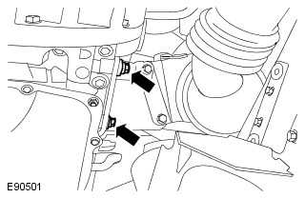 | - Tighten to 30 Nm (22 lb.ft).

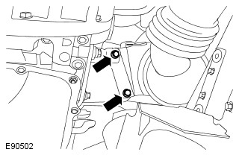 | - Tighten to 30 Nm (22 lb.ft).

- Install new nuts.
  - Tighten to 30 Nm (22 lb.ft).

- Tighten to 20 Nm (15 lb.ft).

- Install the turbocharger heat shield.
  - Tighten to 10 Nm (7 lb.ft).

- Connect the turbocharger electrical connector.

- Tighten to 5 Nm (4 lb.ft).

- Install the air cleaner outlet pipe.
For additional information, refer to: Air Cleaner Outlet Pipe (303-12 Intake Air Distribution and Filtering - ID4 2.4L Diesel, Removal and Installation).

